**Project Framework : Blockchain-Based Algorithmic Trading**

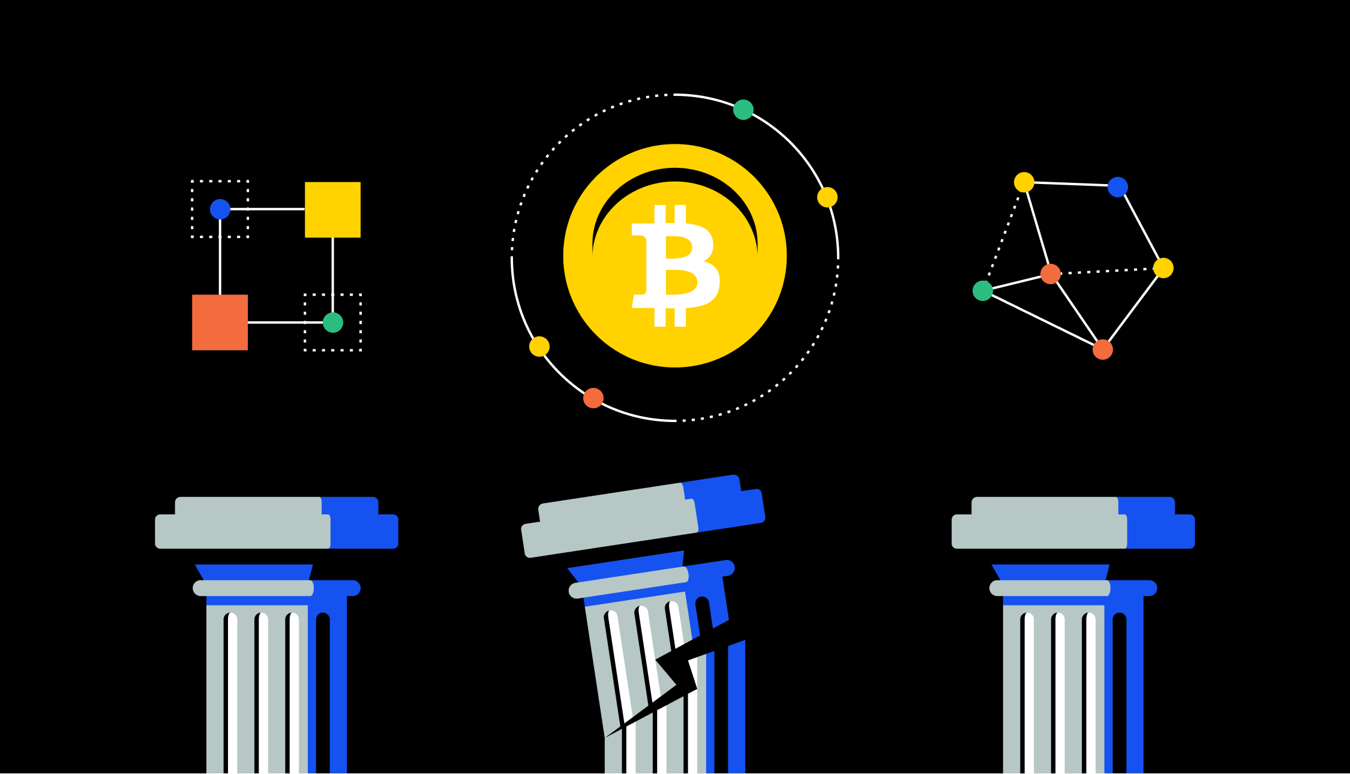

Based on the project components, here's a detailed framework :

1. **Market Research:  
Goal:**Research on the development and adoption of blockchain in financial markets (DeFi, NFTs, tokenized assets).  
Analysis of newly applied problems for algorithmic trading in this field (high-frequency trading, arbitragestrategies, automatic portfolio management).  
Identify key players and platforms driving innovation in the blockchain industry.  
**Challenges:**  
Explore regulatory uncertainties and the lack of a clear basis for blockchain-based financial operations.  
See vulnerabilities and potential manipulation risks in decentralized exchanges and smart contracts.  
Investigating data quality and access issues affecting business algorithms.

**2. Algorithmic Trading Strategies:**

**Fundamental Strategies:**

**Trend following:** Look for algorithms that use energy and trading variables (moving averages, indicators).  
**Mean Reversion:** Analyzing strategies  (statistical models, arbitrage opportunities) that use cyclical values ​​and capital returns.  
**Marketing:** Learn how to make profits and bid-ask spreads in the foreign exchange market (automaticmarket maker).  
**Portfolio Management:** Learn strategies for adjusting portfolios based on market indicators and risk factors.  
**Blockchain Exclusive Ideas:**  
Search on-chain audit data (stock volumes, token stocks) to obtain algorithmic insights.  
Check out arbitrage and liquidity mining strategies based on flash loans.  
Discover the potential of combining artificial intelligence and machine learning in advanced algorithmicdecision making.

**3. Risk Management Framework :**

**Position Size:** Summary of rules for determining portfolio size based on portfolio value, risk tolerance, and volatility.  
**Stop Loss Orders:** Use automated procedures to exit losing positions and limit losses.  
Backtesting and Simulation: Check the effectiveness of historical data by analyzing historical data andsimulated business environment to identify relevant factors.  
**Diversification:** allocating capital to different assets and strategies to reduce losses and build strength.

**4. Performance Metrics Outline :**

**Sharpe Ratio:** Evaluation of risk-adjusted returns with algorithmic strategies.  
**Sortino Ratio:** Measures downside risk and the strategy's ability to preserve capital during  losses.  
**Wedge Ratio:** Measures the maximum drawdown and the strategy's ability to recover from  large losses.  
**Annual Returns:** Track the  percentage of total returns from an algorithm over a specified  period of time.  
**Business costs:** Consider the platform costs (fuel costs) and benefits associated with using blockchain.

**5. Regulatory Insights :**

**Security Management:** Examine the applicability of existing security regulations for blockchain-based assetsand transactions.  
**KYC/AML Compliance:** Evaluate financial security measures and understand customer needs forexchanges and platforms.  
**KYC/AML Compliance:** Evaluate financial security measures and understand customer needs forexchanges and platforms.  
**w** Stay informed about changing laws and regulations affecting blockchain-based financialoperations worldwide.

**Current Market Insights for Blockchain-Based Algorithmic Trading (Jan 20, 2024):**

**1. Market Exploration:**

**Trends :**

DeFi continues to see strong growth, with Total Value Locked (TVL) surpassing $480 billion.

NFTs are experiencing a "utility phase" with increased adoption in gaming, ticketing, and real-world assets.

Institutional interest in blockchain-based assets is growing, with major players like Fidelity and BlackRock entering the space.

**Challenges :**

Regulatory uncertainty remains a significant hurdle, with unclear frameworks for DeFi activities and security tokens.

Interoperability between different blockchain networks is limited, hampering broader adoption.

Security vulnerabilities and exploits continue to pose risks to decentralized exchanges and smart contracts.

**2. Algorithmic Trading Strategies:**

**Fundamental Strategies :**

Trend-following algorithms like MACD and RSI are showing mixed results due to recent market volatility.

Mean reversion strategies are seeing some success in capturing short-term price swings in high-liquidity tokens.

Market making bots are experiencing increased competition, leading to tighter bid-ask spreads and lower profit margins.

**Blockchain-Specific Strategies :**

On-chain data analysis has proven effective in identifying undervalued tokens and potential market movements.

Flashloan-based arbitrage opportunities are becoming increasingly sophisticated and competitive.

AI and machine learning integration is still in its early stages but holds significant potential for advanced algotrading.

**3. Risk Management Framework :**

**Position Sizing:** Consider a conservative approach with smaller order sizes due to volatile market conditions.

**Stop-Loss Orders :** Tightly set stop-loss orders to minimize potential losses during sudden price drops.

**Backtesting and Simulation :** Backtest algorithms thoroughly using historical data and stress test them against different market scenarios.

**Diversification :** Diversify across different blockchain networks, asset classes, and trading strategies to mitigate single point of failure risks.

**4. Performance Metrics Outline:**

**Sharpe Ratio :** Focus on Sharpe Ratio and Sortino Ratio to evaluate risk-adjusted returns and downside risk control.

**Maximum Drawdown :** Monitor maximum drawdown closely to assess the algorithm's resilience during volatile periods.

**Transaction Costs :** Account for gas fees and platform commissions which can significantly impact profit margins.

**5. Regulatory Insights:**

The SEC is actively investigating DeFi activities and has cracked down on several projects suspected of security violations.

G7 nations are collaborating on developing harmonized regulatory frameworks for crypto assets.

Regulatory clarity is expected to emerge gradually, potentially impacting market dynamics and trading strategies.